A Visual Comparison of the Original and Newer Versions of the M-Editor and M-Debugger in Eclipse
Prepared for the VistA Community Meeting, January 16-18, 2015 by Joel Ivey.

This document is a companion, for those who want it, to the PowerPoint presentation on the M-Editor and other M tools for Eclipse. This is largely images for the M-Editor and M-Debugger in Eclipse (the old version and the new version). This is the picture book version, and is not expected to be printed out, since there would be a lot of white space. It is expected to be read in a document file reader. The images should probably be extractable, and many are much larger than shown here.

We begin with the old version of the M-Editor (working in the VISTA namespace)

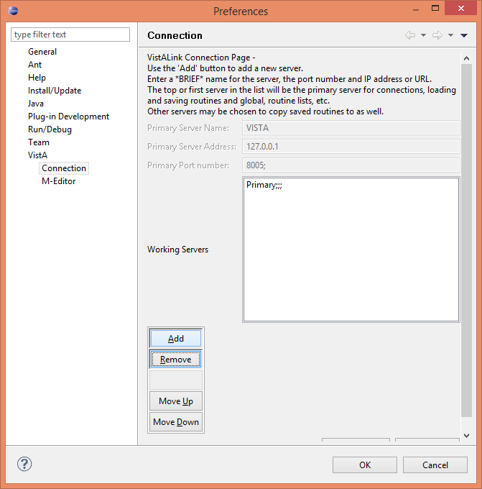
The VistA Connection Property form on first opening the system (;;; is not a valid server specification).

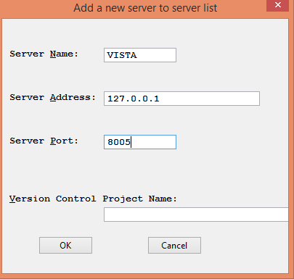
Clicking on the Add button brings up this form for entering the server name, the address and port number. Version Control Project Name is entered only if the directory will be under source control.
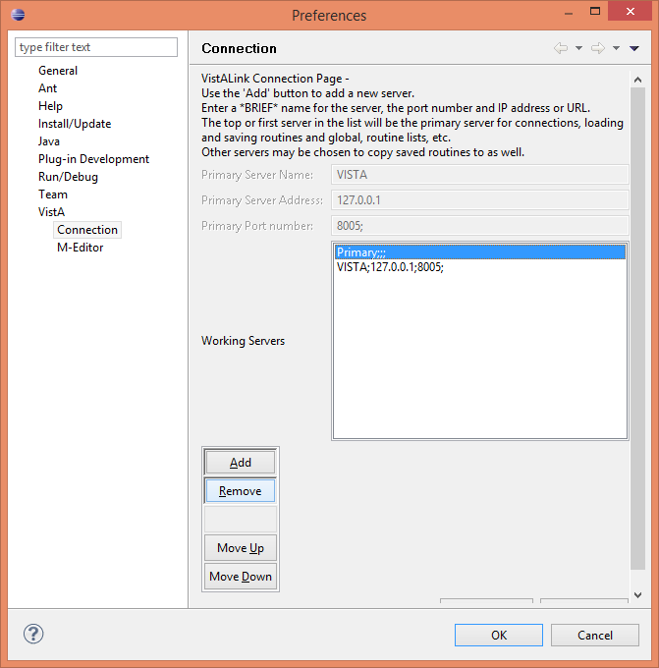
After clicking OK, the added server shows up in the list. There may be multiple servers listed, but only the top server in the list is considered to be the active server from which routines are loaded from. If there are multiple servers listed, on saving a routine, an option will be displayed to permit the saved routine to be saved to other servers as well. The choice (of not going to any others, or going to one or more other servers in the list) can be set with a don’t ask again check box.
Here, the default empty server is selected, and is ready for the Remove button to be clicked.
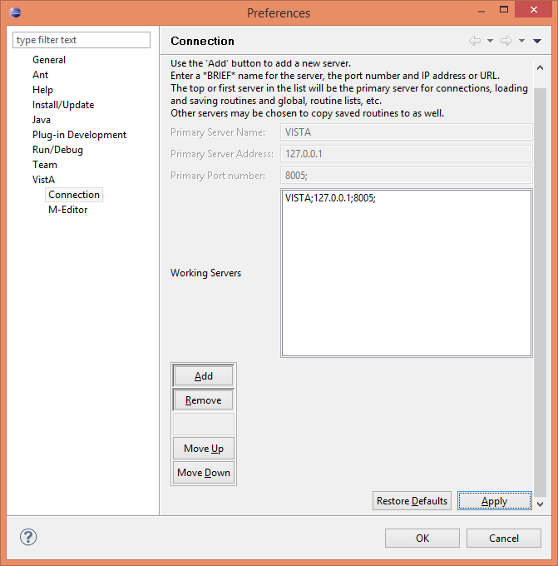
After the default empty server specification has been removed, the newly added server is the top (and only at the moment) server, so it is the default server for connections.
If there is more than one server to be selected, and another server is moved up to the top during the processing, a notice will be given the next time a server is contacted indicating that the server has changed, and the user may need to sign into the newly selected server.
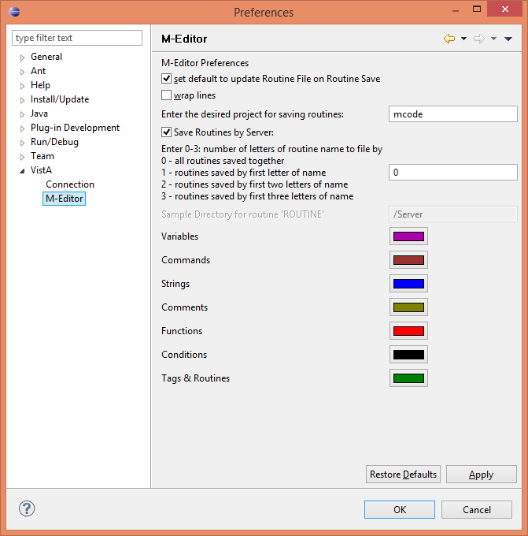
The VistA | M-Editor preference page.
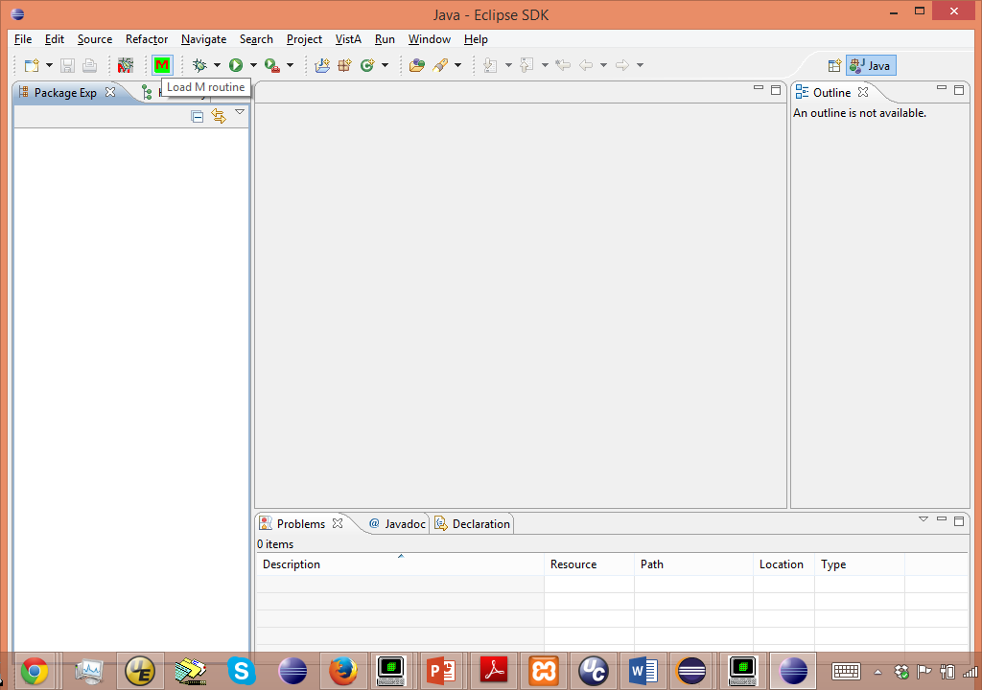
Loading of a routine is initiated with the red M on a green background icon or selecting the VistA | Load M Routine menu option.
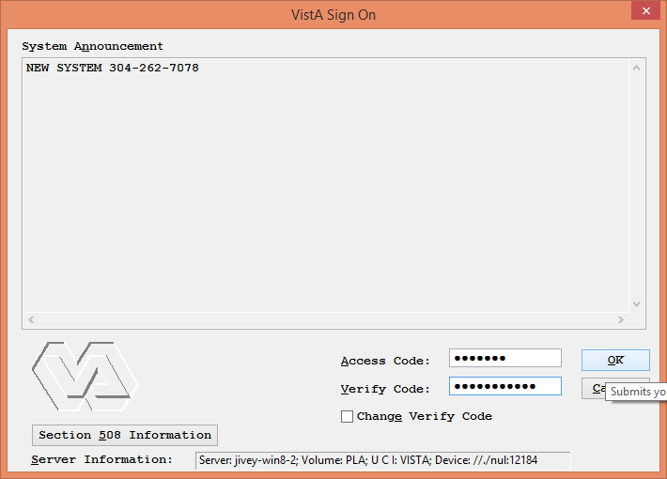
Which brings up the VistA sign-on dialog.
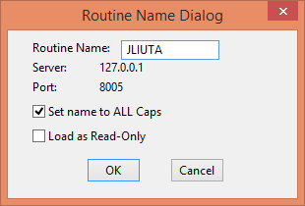
And, after signing on, the Routine Name Dialog form.
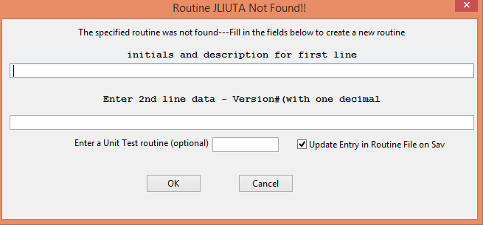
Normally, the routine would be loaded. But, in this case, the routine JLIUTA is not present, which brings up a form to create a new routine, if desired.
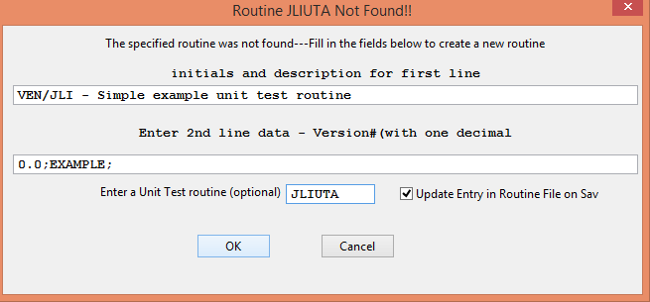
Entering the information for the first and second lines (there is a text box for the Unit Test routine as well, but apparently, it wasn’t stored correctly).
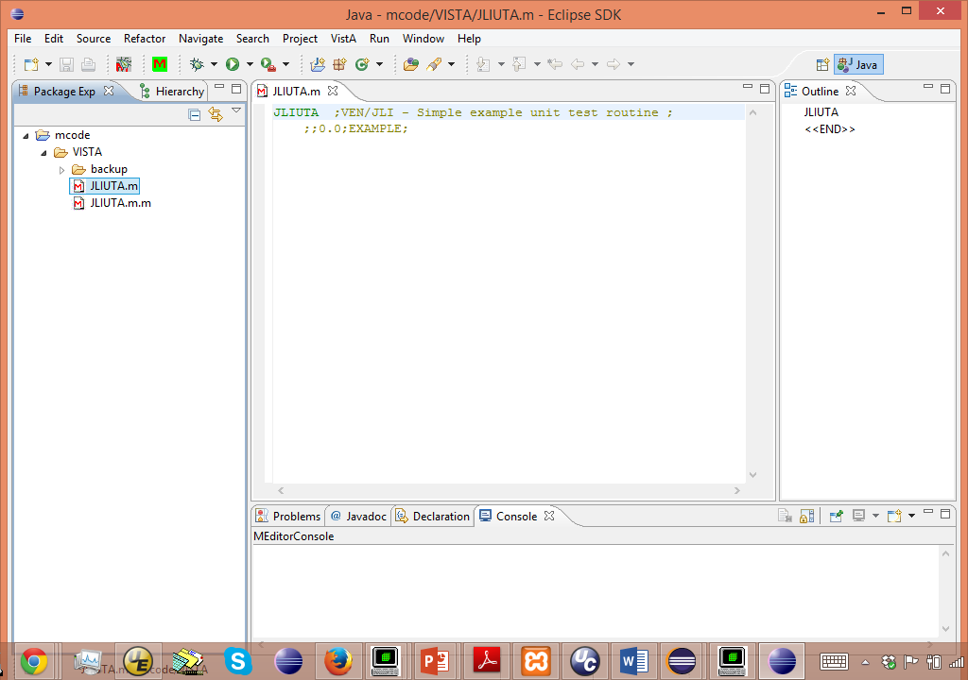
The newly created routine ready for editing. It has been selected in the project folder listing to the left, and right clicking on the routine name and selecting properties brings up the properties for the file.
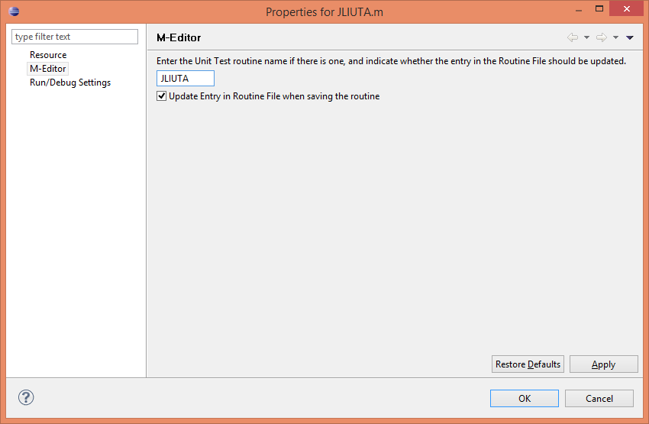
And selecting the M-Editor item, the routine was entered for its own unit test routine (it should have been entered from when the routine was created, but apparently it didn’t take). This is also how a unit test routine can be specified for an existing routine.
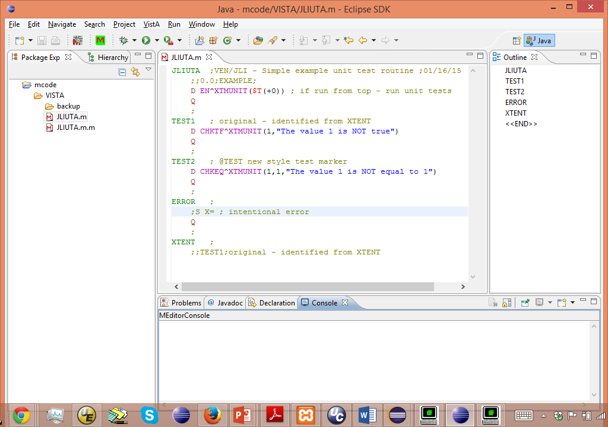
Some simple example code with two unit test tags (one the original style specified under the XTENT tag, and the other using the @TEST specification on the tag line). An ERROR tag was created simply to create some error code, but commented out.
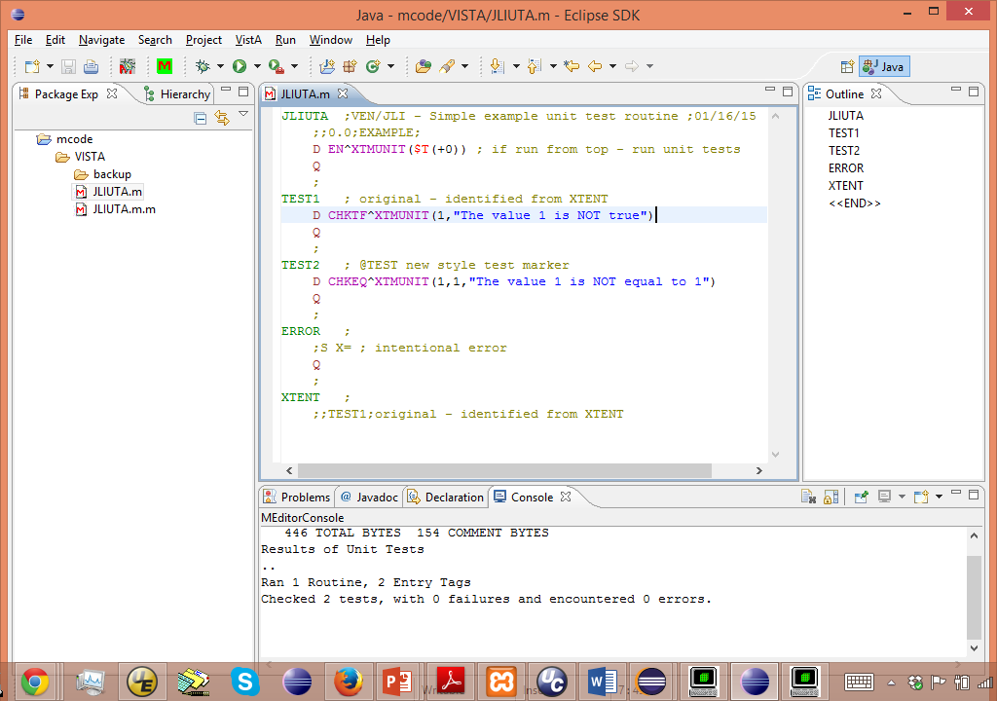On saving (by selecting the floppy disk [the second icon for those not familiar with floppy disks] or entering Control-S. The results for the saved routine are shown in the lower (MEditorConsole) panel, indicating no errors encountered, and showing the results of the unit tests.

And now the newer version of the M-Editor (working in the VISTA1 namespace)
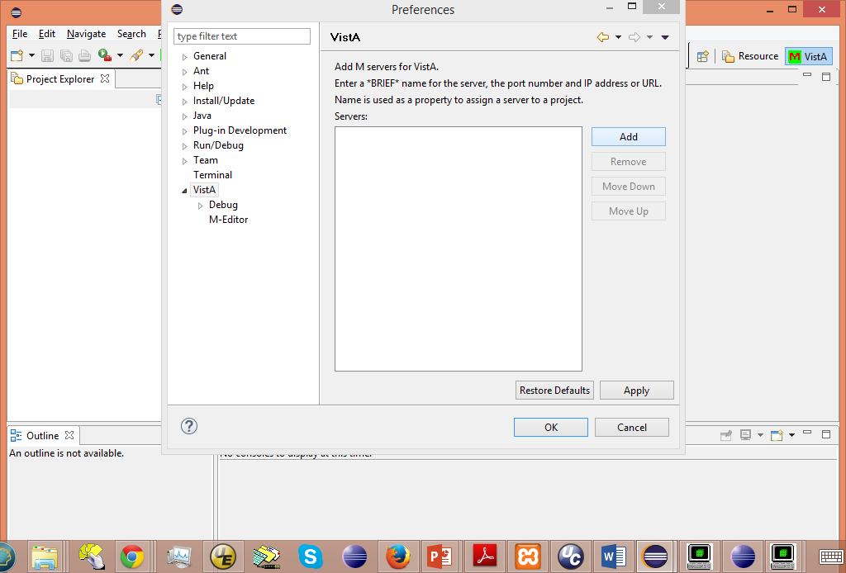
The connection preferences are in the VistA preference page itself.
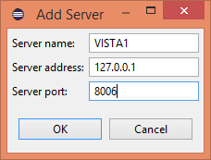
Clicking Add brings up the form to add server information.
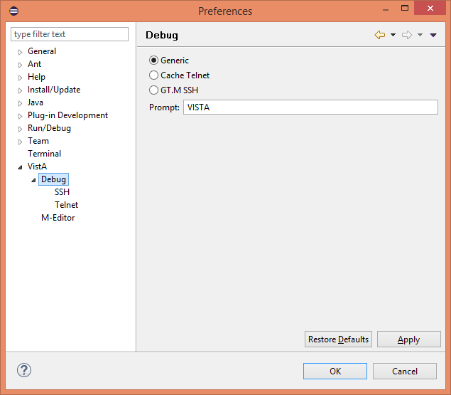
After adding the server, there is a new Debug preference form, which was left with the default of Generic VISTA.
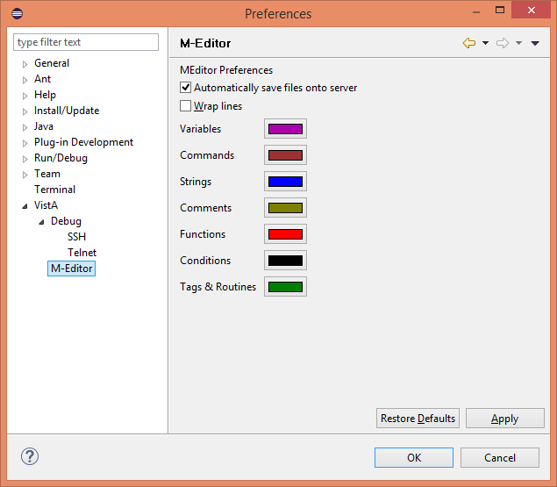
And a slightly modified M-Editor preference page.
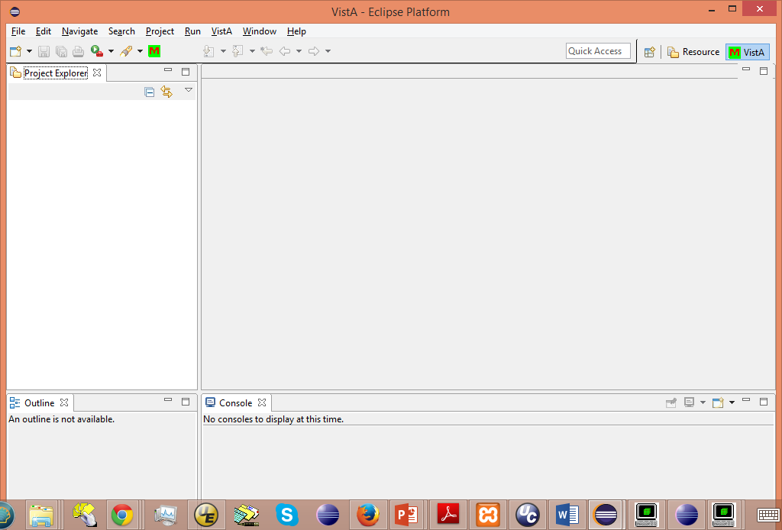
The M-Editor perspective doesn’t show much, and needs a project to work with.
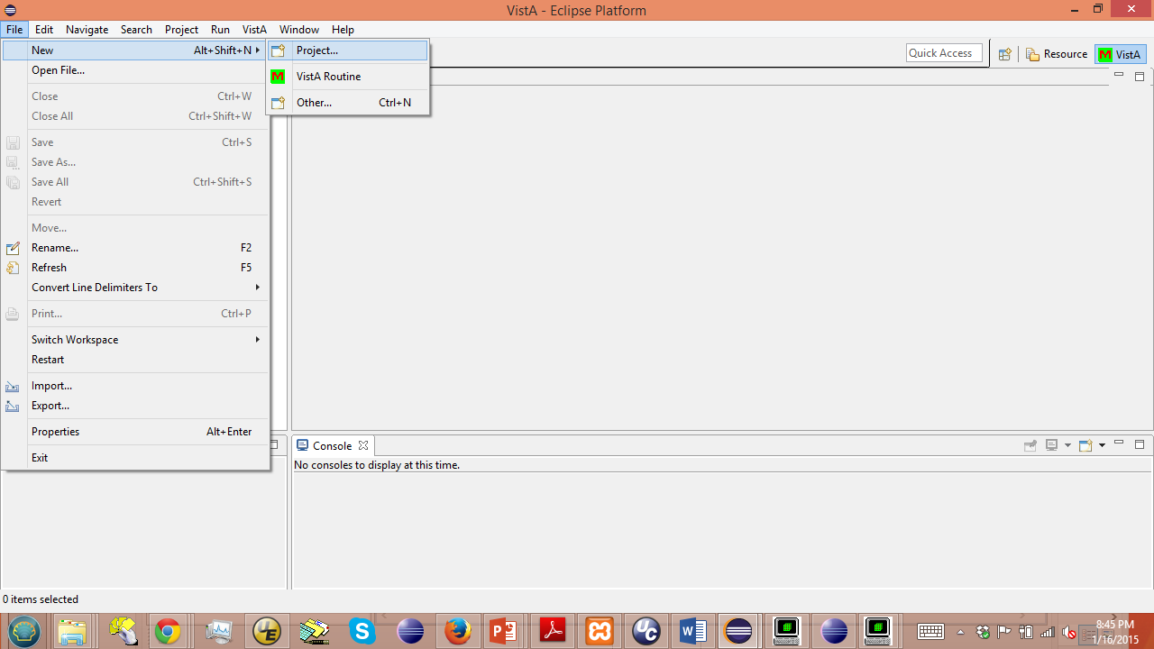
A new project is created by selecting the File | New | Project option
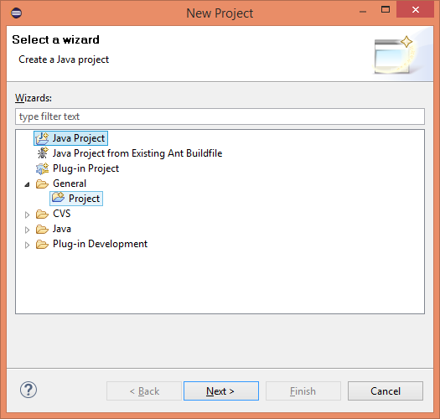
And selecting a General | Project, and Clicking Next
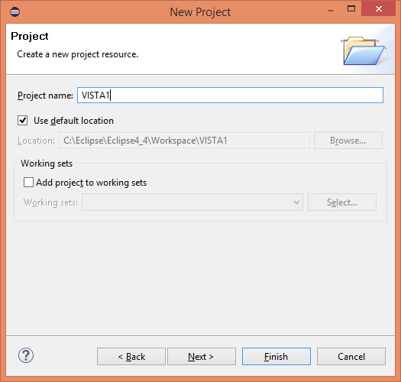
and then entering the project name as (in this case) VISTA1.
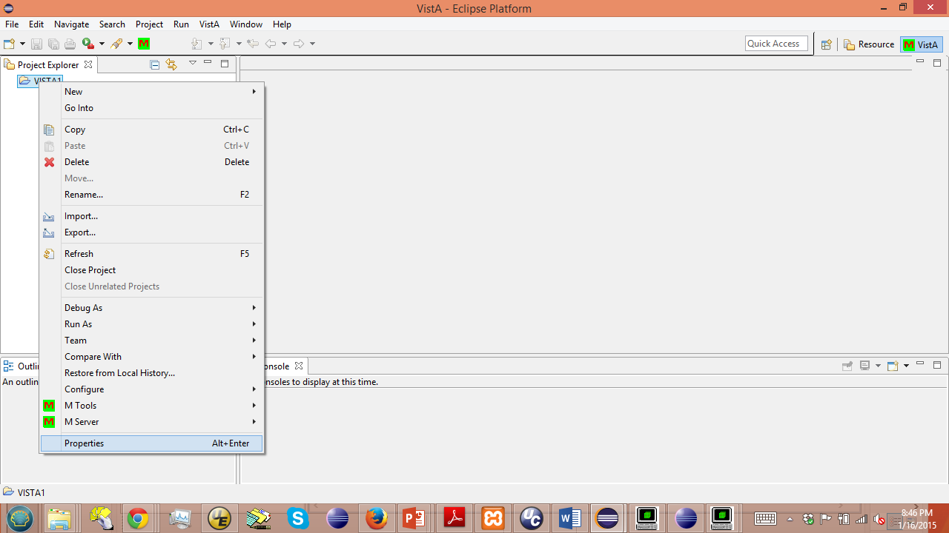
And then select the project, right click and select Properties.
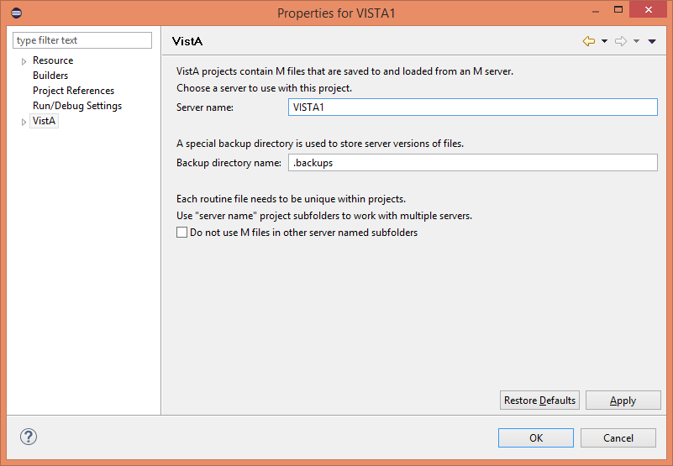
Select the VistA page of properties, and enter the server name to be associated with the project.
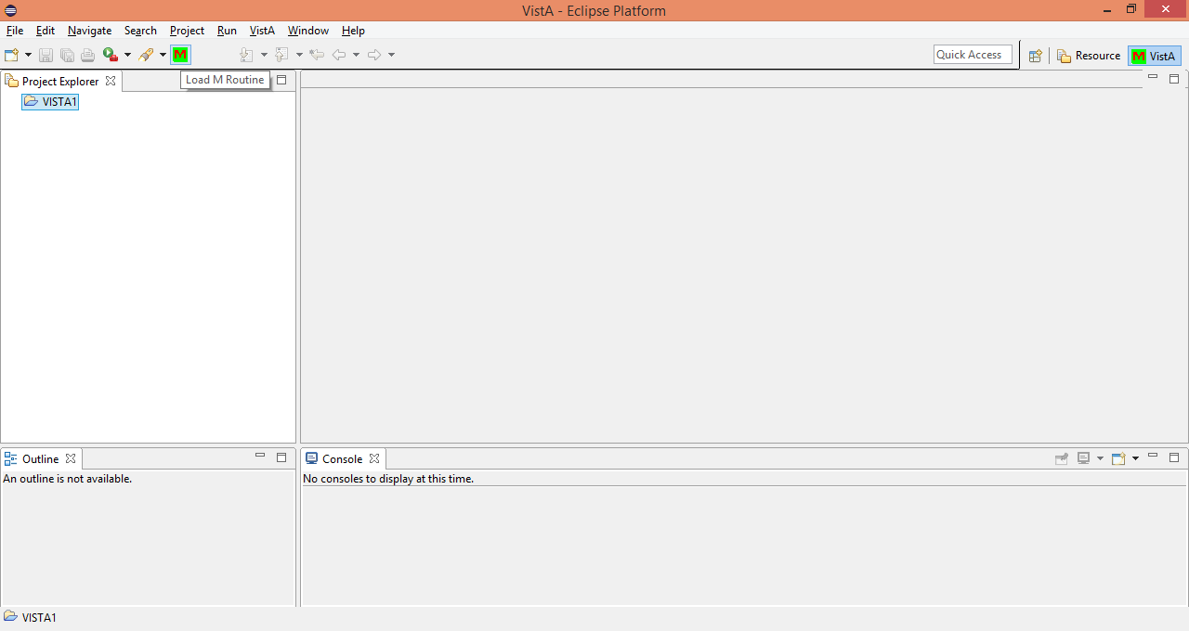
Now the Load M Routine icon or the VistA | Load M Routine option selected to load a routine from the server.
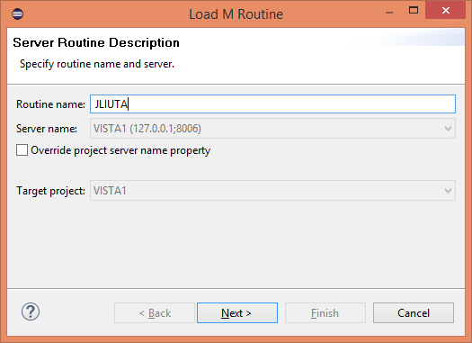
Enter the name of the routine to be loaded (and it will not permit lower case letters as part of the routine name, even though the open source version of the M unit test routines is in the %ut namespace – so they can’t be loaded into the newer version of the M-Editor).
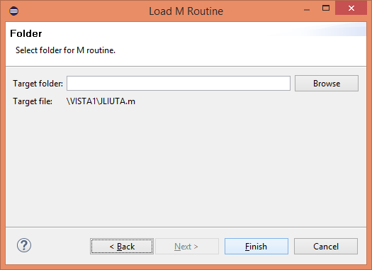
And to select a folder (using the default in most cases) for the routine to be stored in.
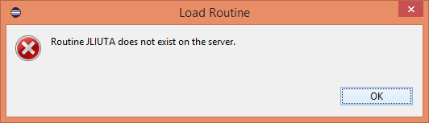
In this case, if the routine is not on the server, it simply indicates that.
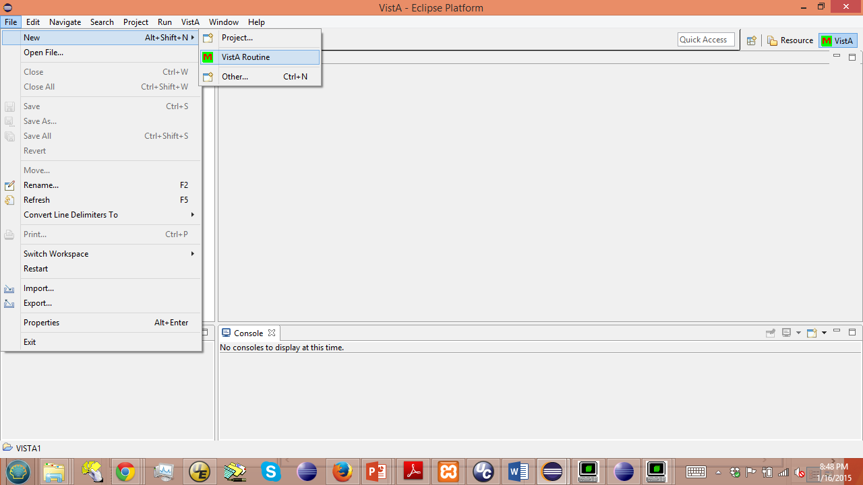
To create a new routine which is not currently on the server, the user has to select File | New | VistA Routine.
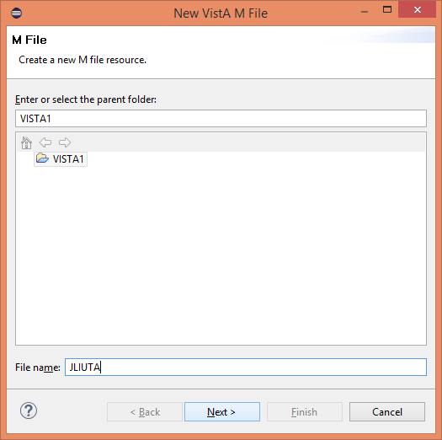
Enter a file name, and
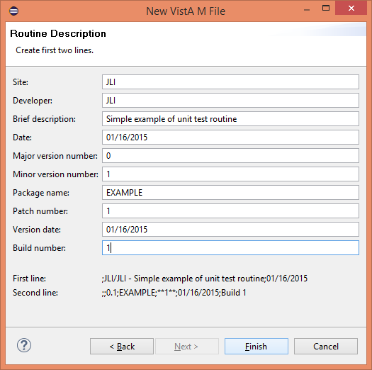
Fill in all of the fields for the first two lines, then clicking Finish. 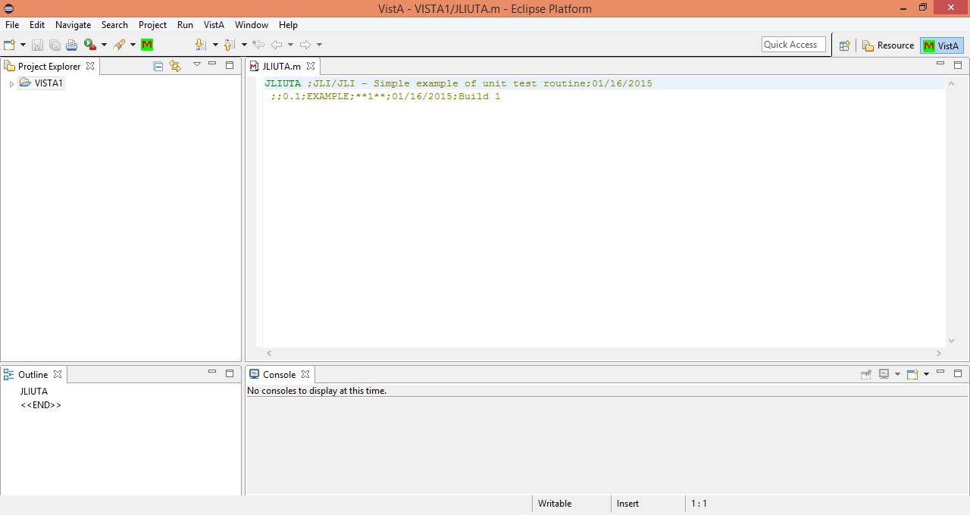
To create the new routine.
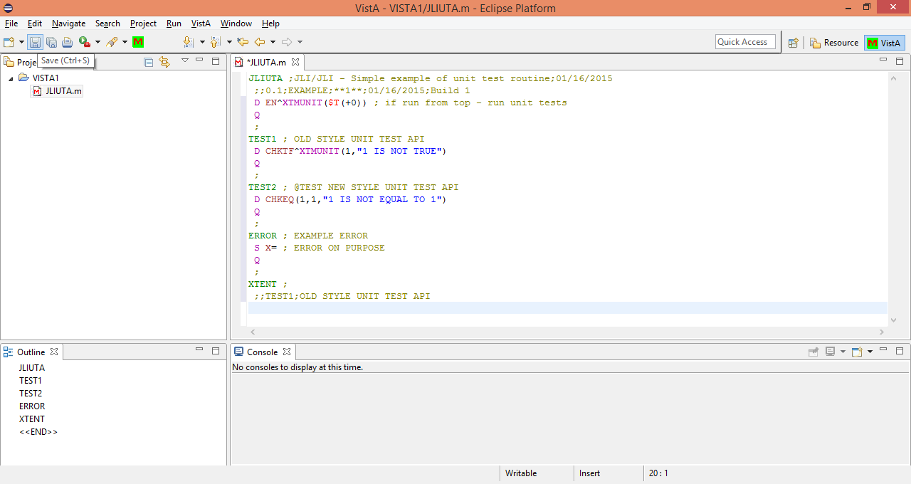
And entering much of the same code from the version in the older version of the M-Editor, and clicking on the Save icon.
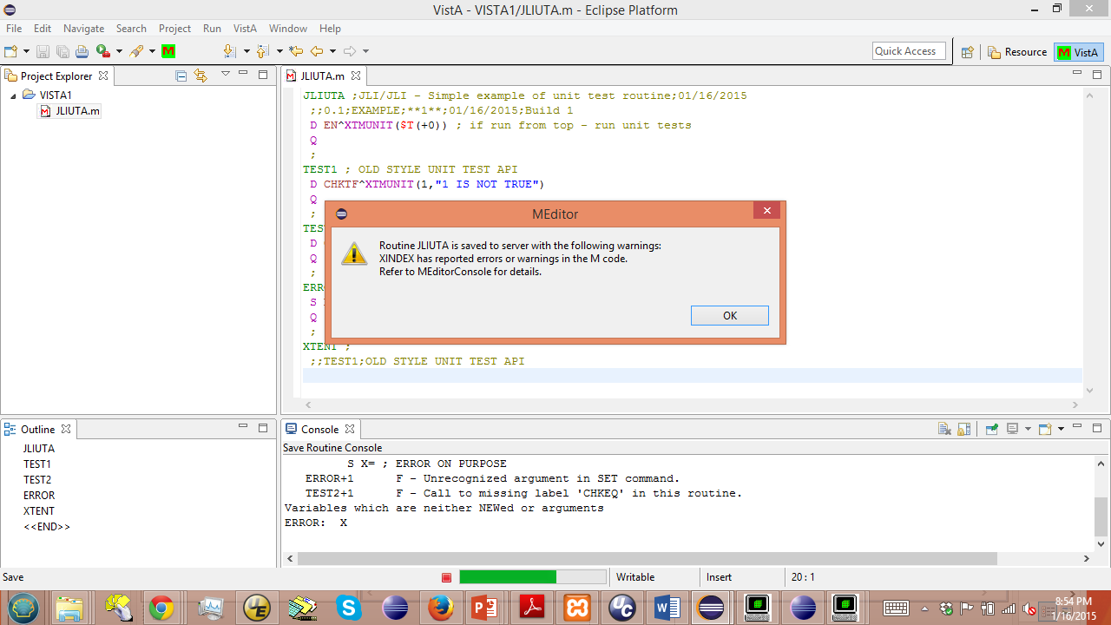
It does recognize some problems
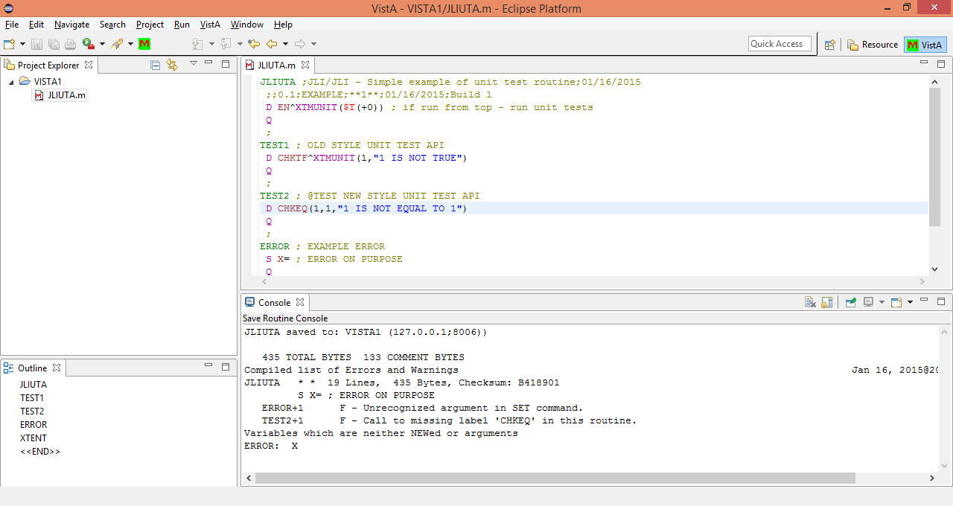
with the Error line, and also a typo in leaving out the ^XTMUNIT for the call to CHKEQ. It does not run the unit tests, since there is no property available to specify that name.
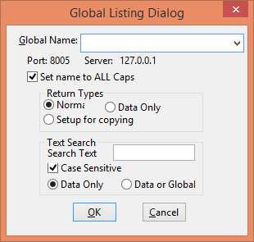
The Global Listing dialog form for the older version of the M-Editor
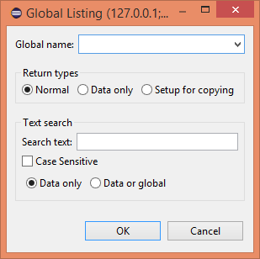
The Global Listing entry form for the newer version of the M-Editor

The M-Debugger in the original version of the M-Editor/M-Debugger
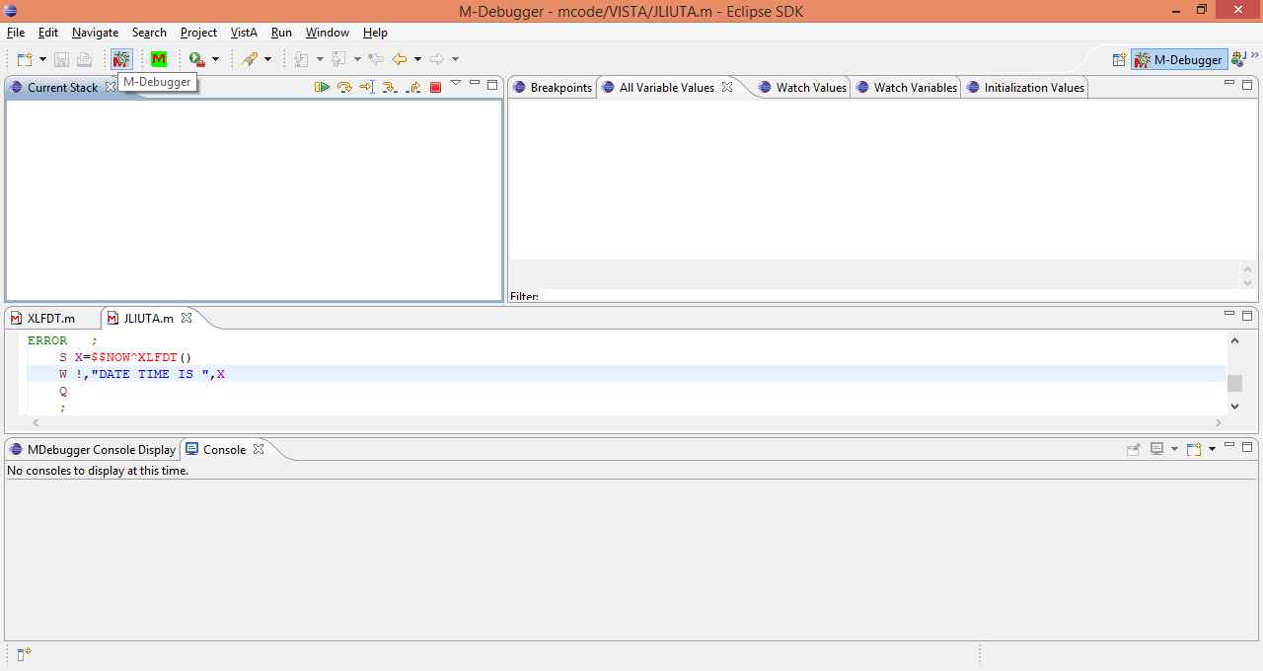
In the original M-Editor/M-Debugger version, clicking on the red M icon with a bug on it
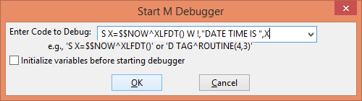
Opens the M-Debugger dialog box. Enter any command to be executed in the text box.
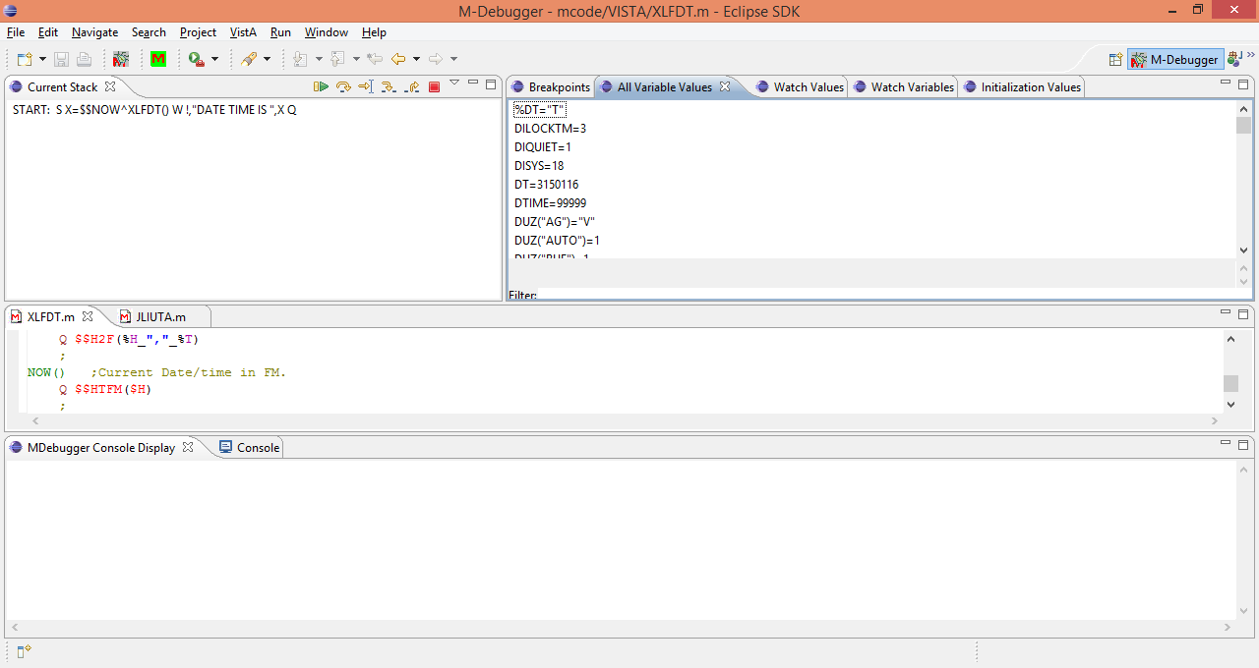
Clicking OK, opens the M-Debugger Perspective at the start location.
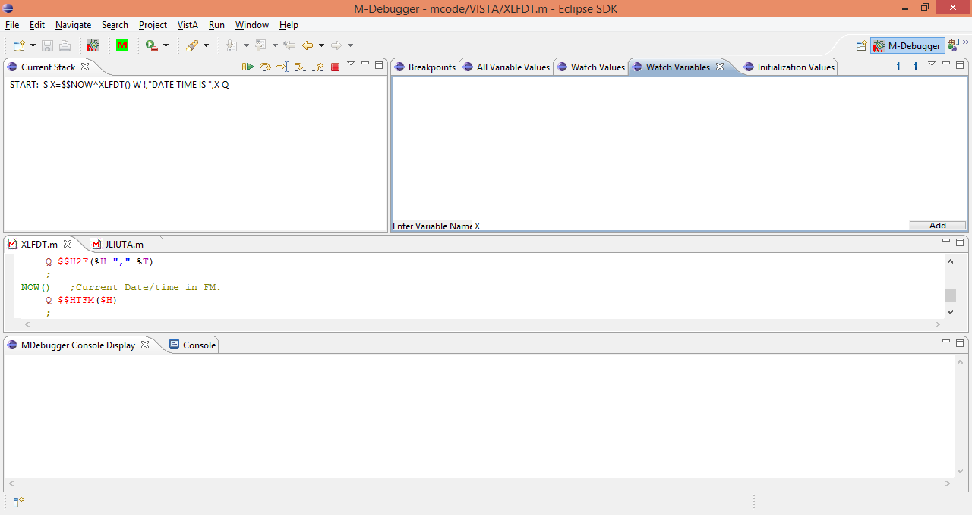
Select the Watch Variables tab and enter a variable (e.g., X) then click Add
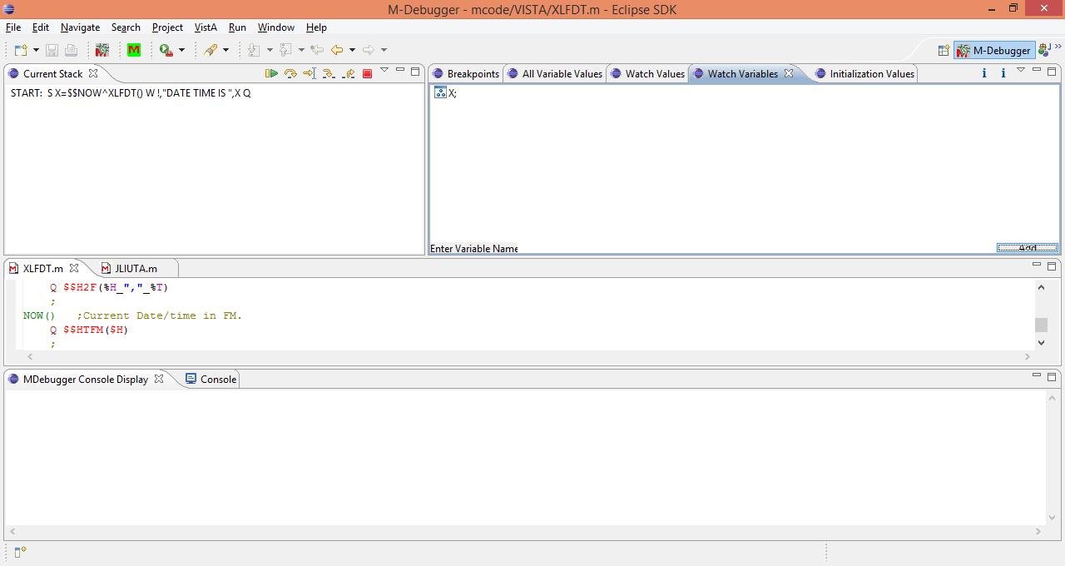
To set up a watch variable. This will cause the process to stop any time that a watch variable value changes.
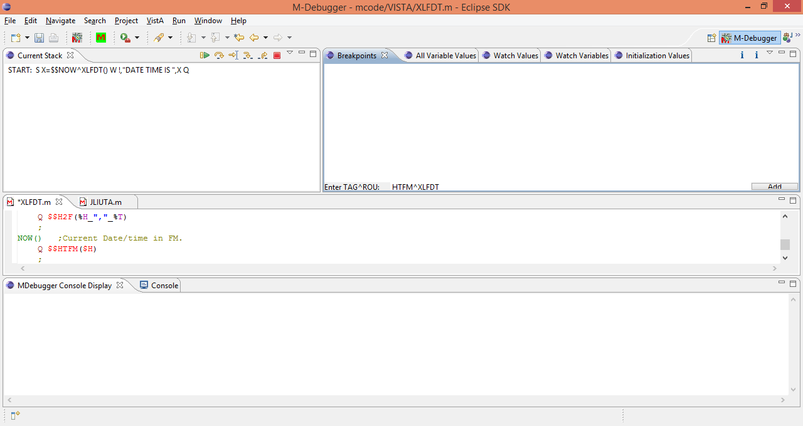
Select the Breakpoints tab and enter a TAG^ROUTINE name (e.g., HTFM^XLFDT) and click Add to enter a breakpoint 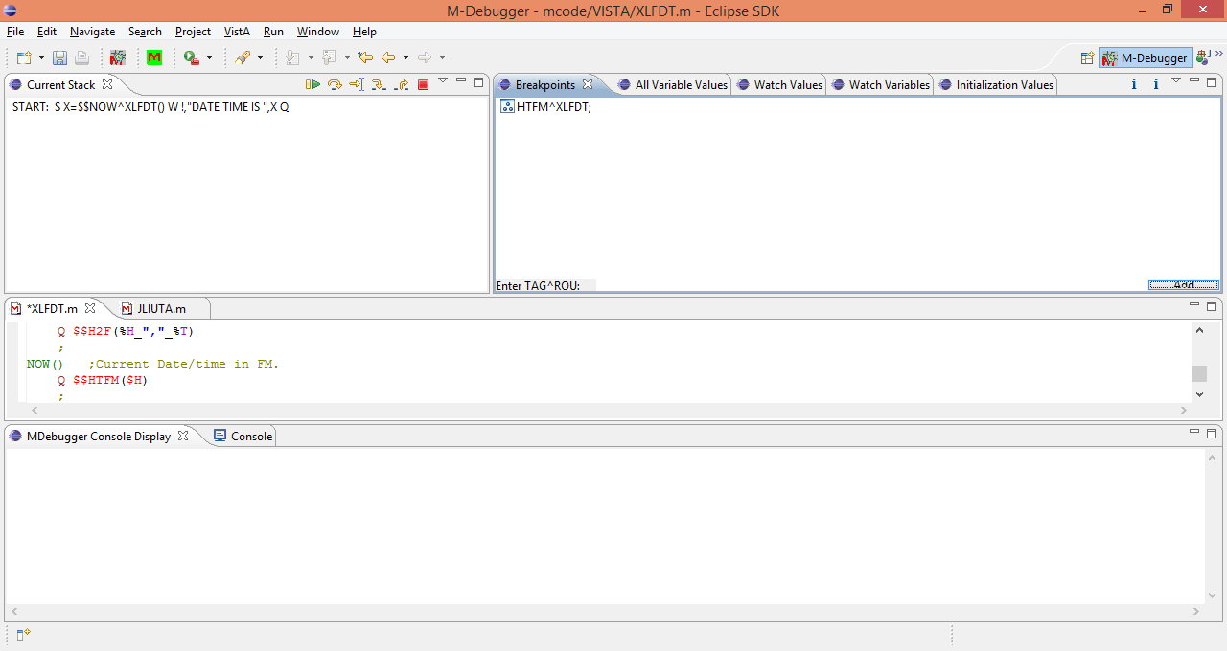
which will cause the processing to stop when a breakpoint is encountered.
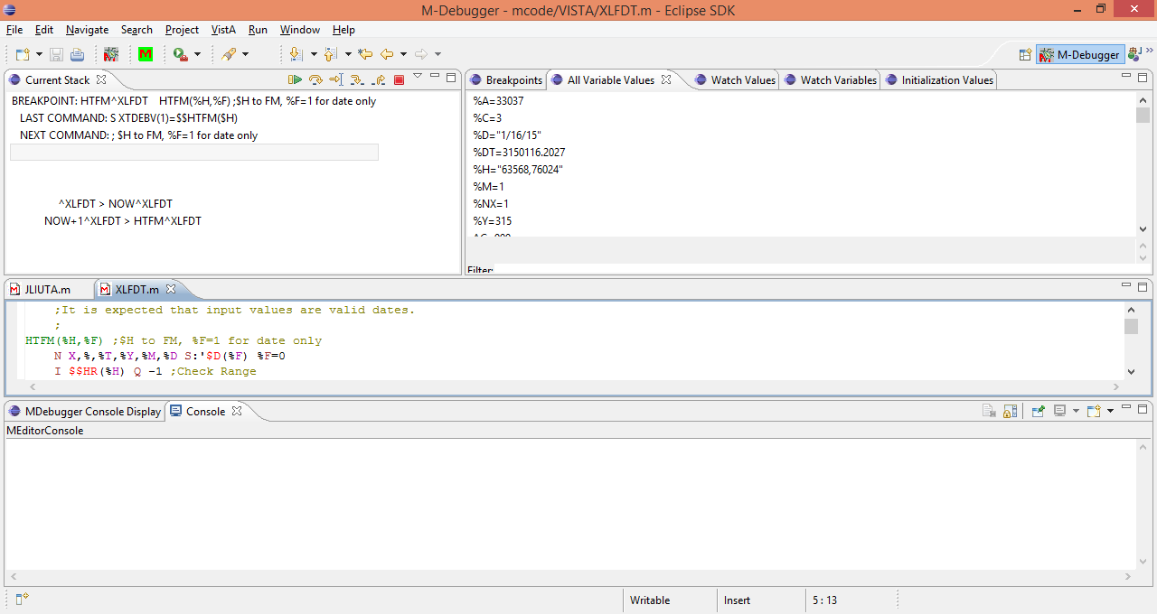
Clicking the run icon (the first to the right of the Current Stack tab) causes the process to run until it encounters a change in a watched variable, a breakpoint, or completes the processing. Here it is shown having reached the HTFM^XLFDT breakpoint.
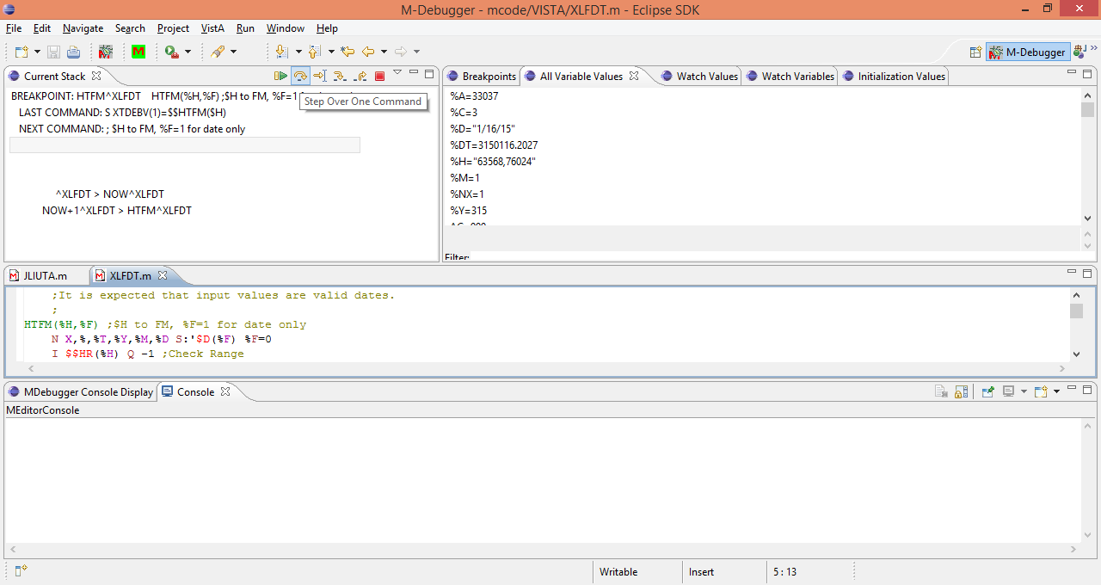
Selecting the second icon will cause the processing to continue one command at a time.
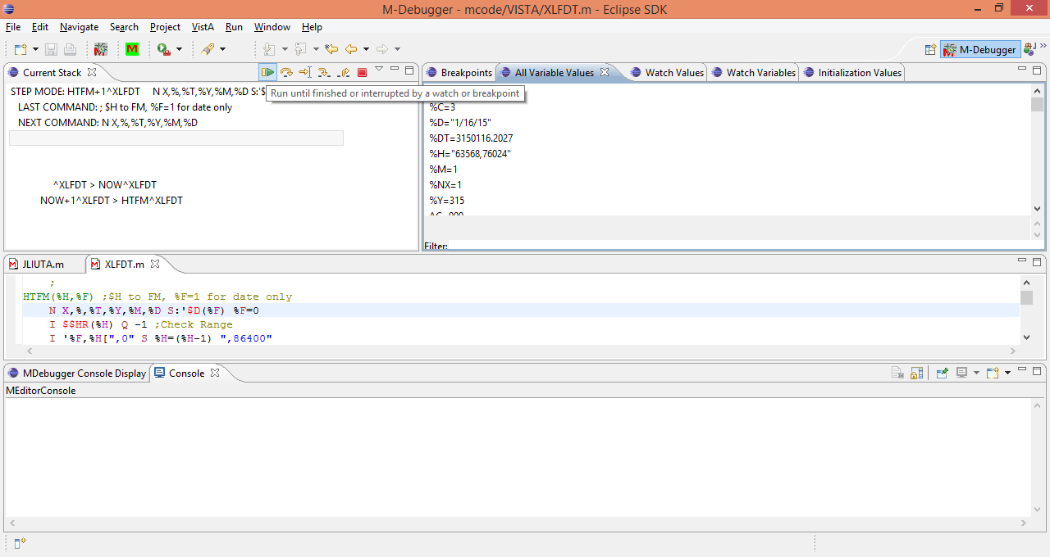
And returning to the Run mode
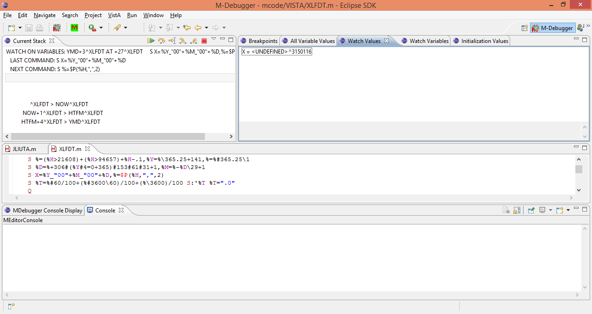
Encounters a change in the Watch Variable X from undefined to 3150116.
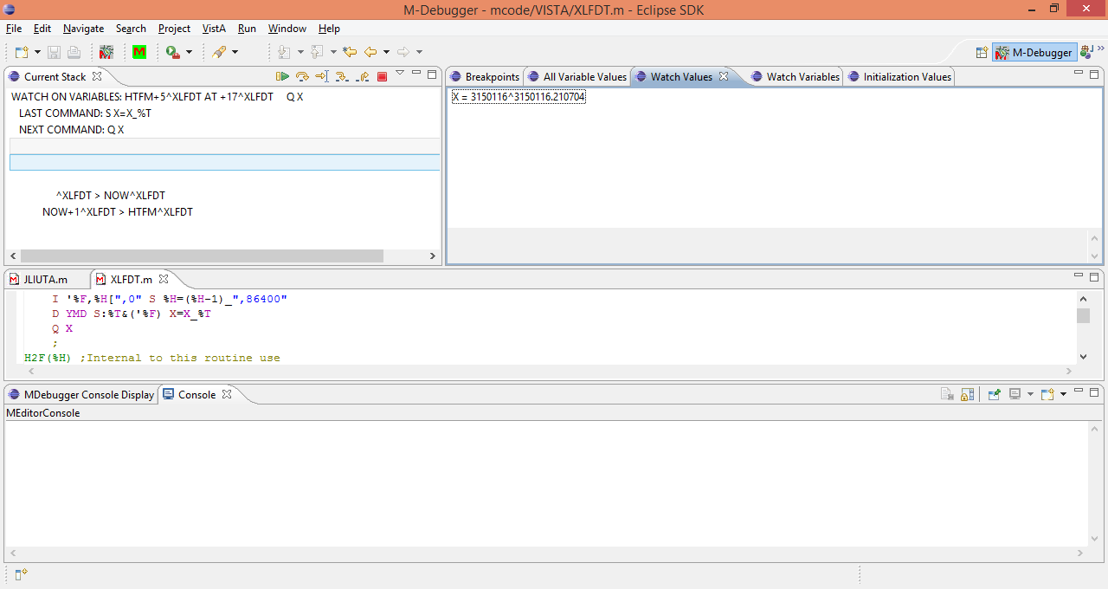
Continuing to run encounters another change in the watch variable X from 3150116 to 3150116.210704.
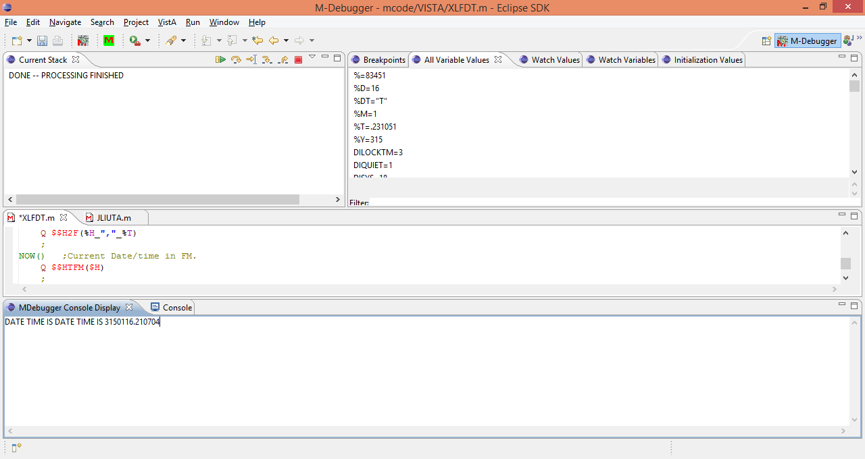
And selecting Run again continues until the processing is finished including the write statement to the MDebugger Console Display in the lower panel.

The M-Debugger in the newer version.

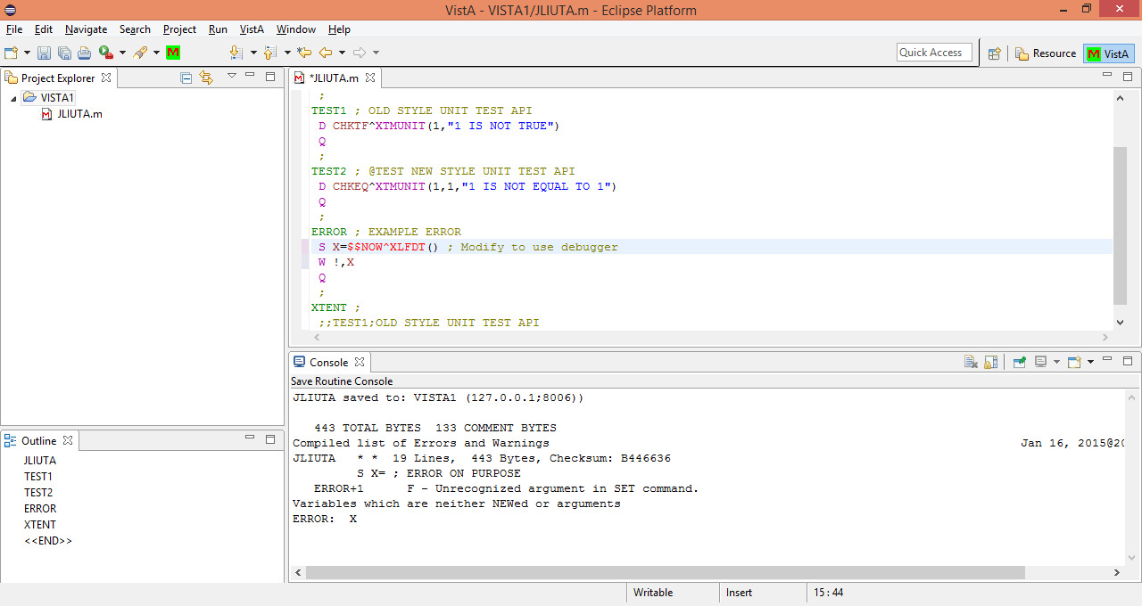
The code at the tag Error was changed, since the newer version wants the debugger to start at a specified tag in a specific routine. Also, the routines referenced must already be a part of the project, so the XLFDT routine has to be loaded before it the newer version of the debugger can work with it.

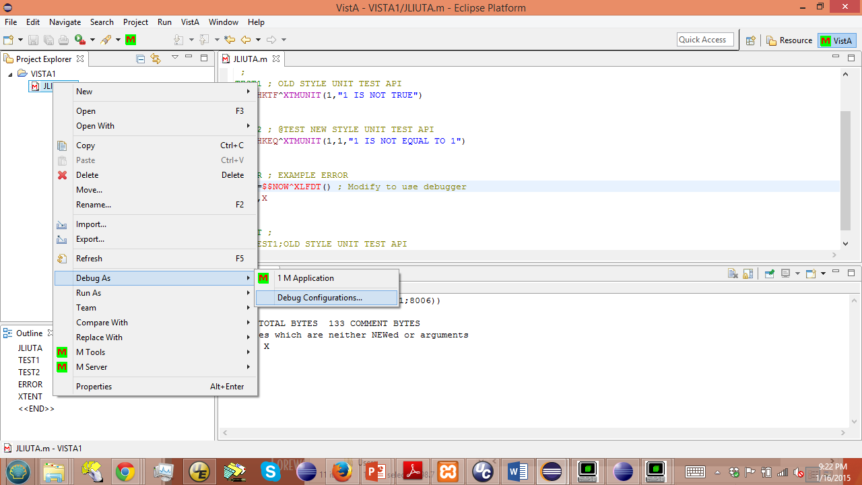
In the M-Editor perspective, select a routine and right click it, then select Debug As and Debug Configuration.
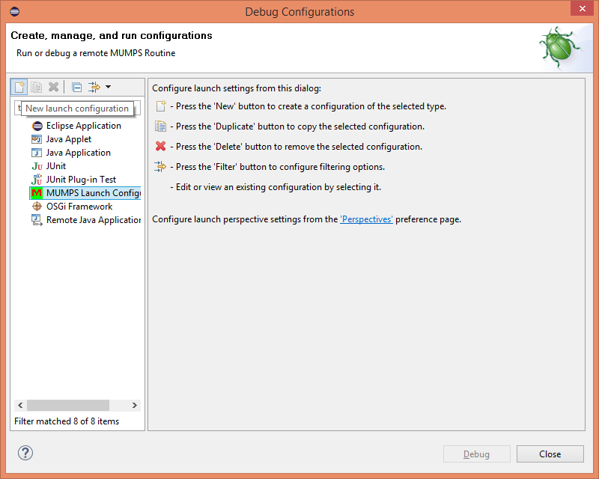Select the MUMPS Launch Configuration, and then the left most icon at the top (with a small plus sign on it) to create a new configuration.
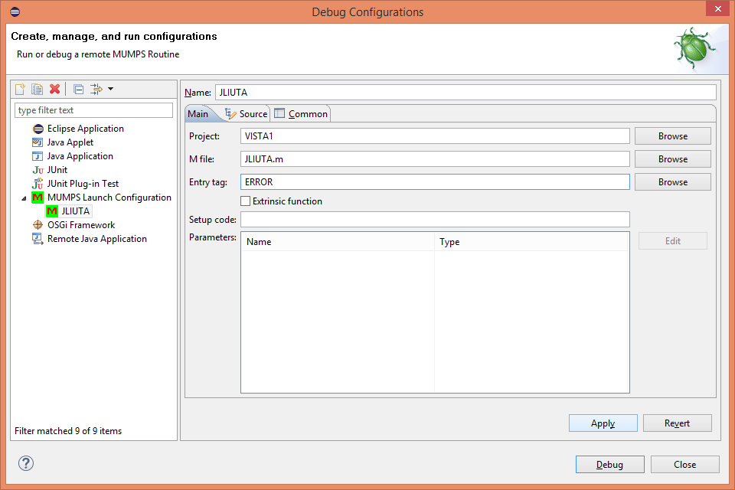
Enter the Entry Tag for debugging to begin. Check the Extrinsic function box if it is one, and enter any setup code necessary (none in this case). Then click Apply and Close.
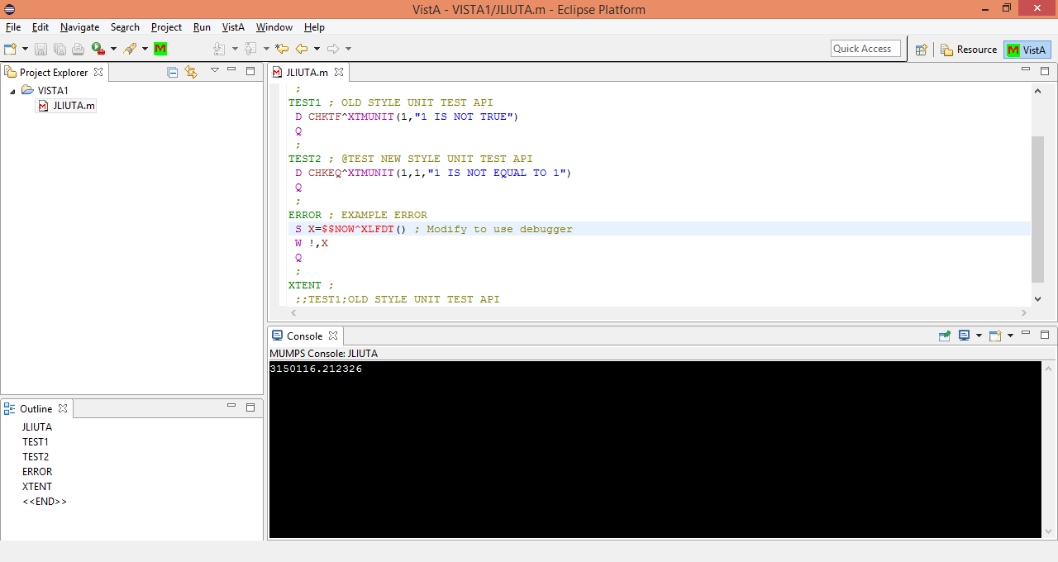
To open another perspective, select the small icon with the plus on it just to the left of the Quick Access notation in the upper right.
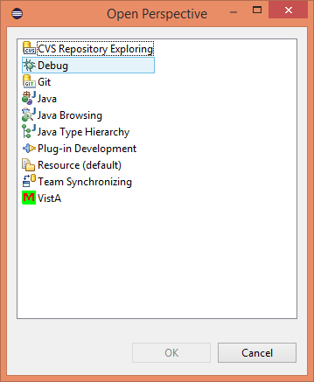
Then select the Debug perspective and click OK
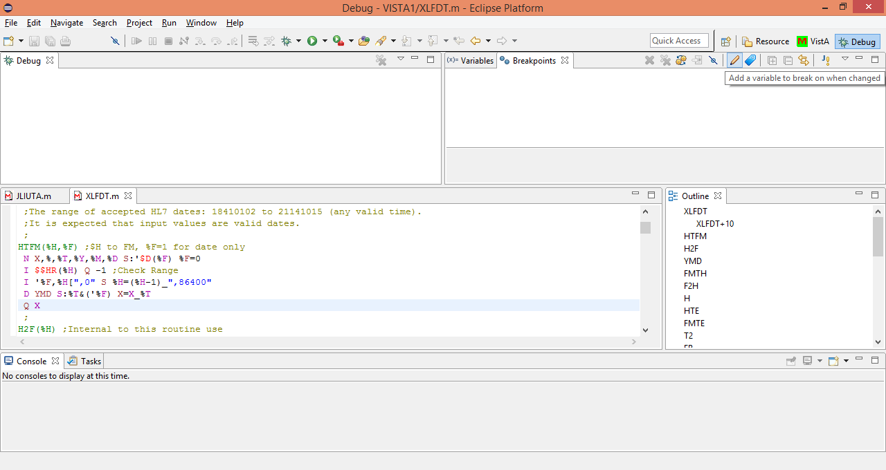
Click on the pencil like icon in the row along the breakpoints tab
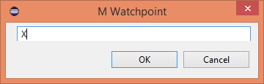
And enter a watch point (watch variable)
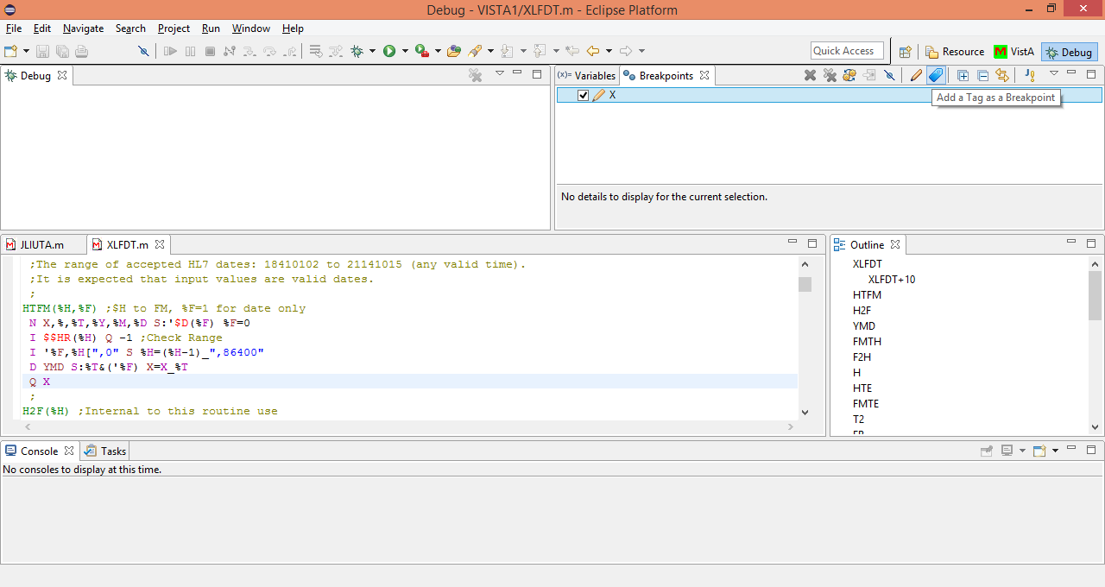
Click on the tag icon next to the pencil to enter a breakpoint
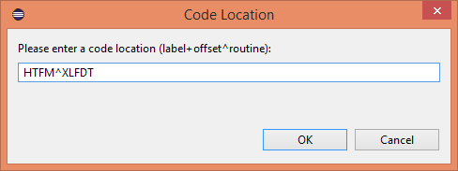
Enter the TAG^ROUTINE and click OK
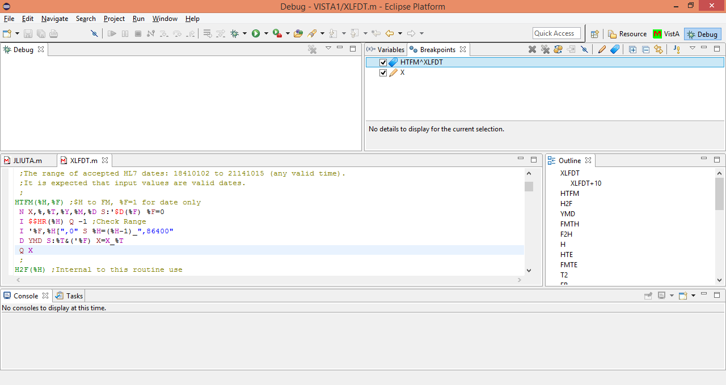
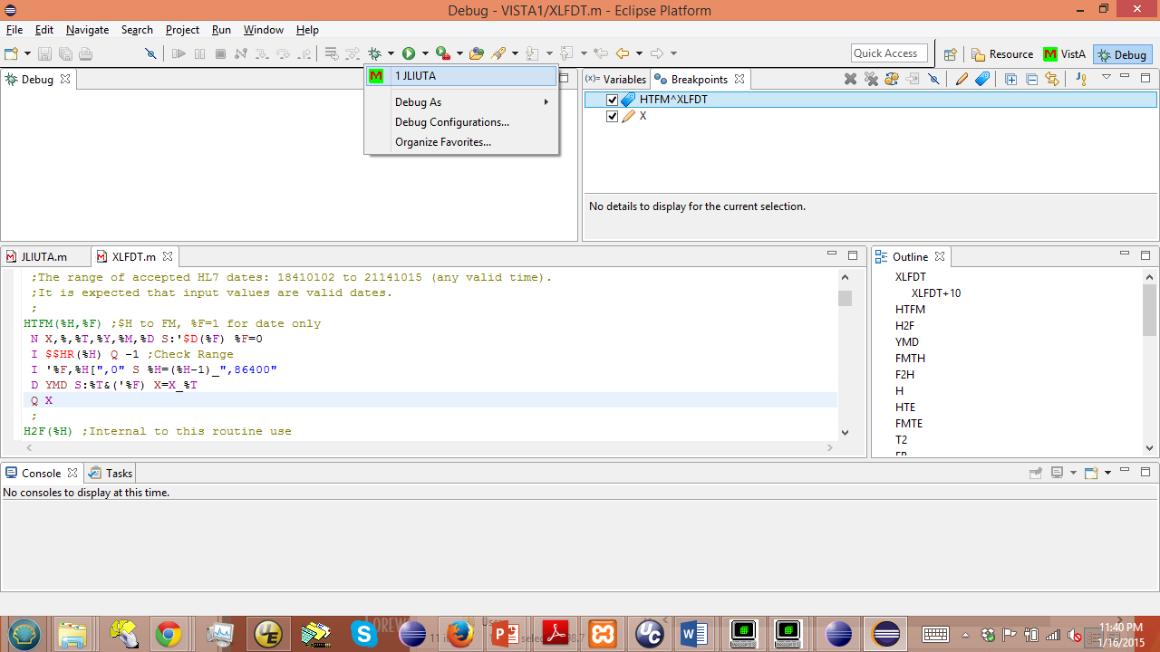
Click on the arrow next to the bug icon to select the configuration for debugging.
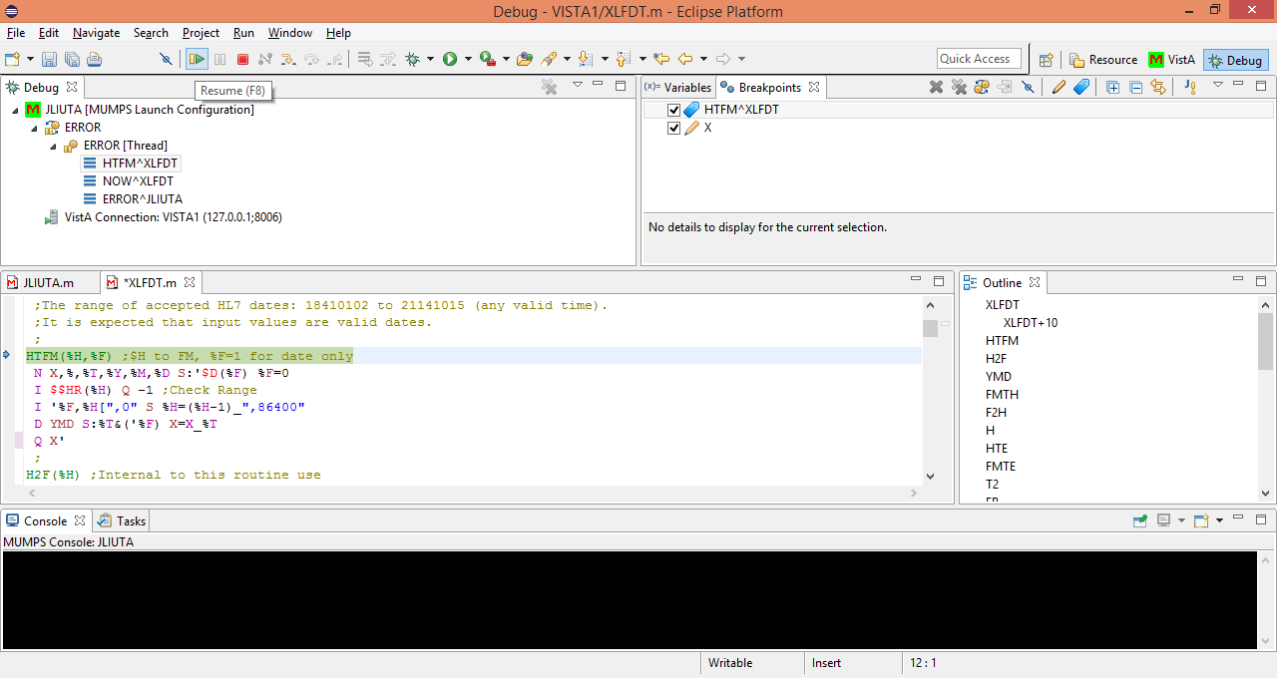
Clicking on the desired configuration (JLIUTA in this case) starts the debugging process, which interrupts due to the breakpoint at the HTFM tag (The references to ERROR shown are due to the poor choice of tag name and not due to any errors in processing). Clicking the Resume button continues the processing.
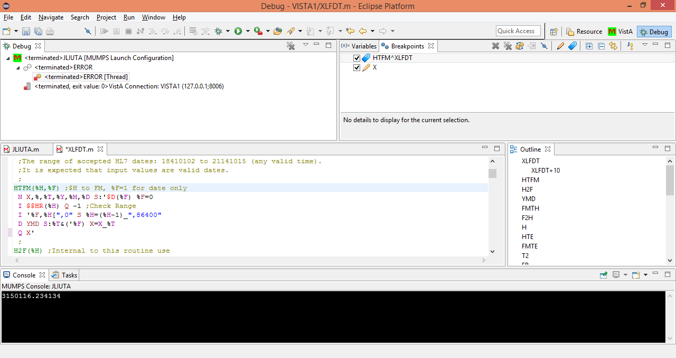
Which results in completion of the process, including output of the value of X in the bottom panel. Unfortunately, there were no breaks due to changes in the value of X encountered.

And that is a summary of most of the features of the original version and the newer version of the M tools in Eclipse.

